**Time Warrior**

Concept And Pitch

Team BMP

Game Title:

Time Warrior

Genre:

Action RPG

Platform:

PC

Premise:

Travel through the ages to gain redemption, and “freedom.” Fight, explore, loot, and level by yourself or up to 3 friends.

Back story:

You are a prisoner of war who is being punished for your crimes by being put through the Colosseum of Time. Your freedom is offered if you can survive and defeat the champions of the eras.

Target Audience/Market:

Teen-RPG/Adventure gamers

Player Motivation:

New areas unlocked in older areas with new powers.

Loot gaining

Adventuring with friends

Fighting through challenging enemies and bosses.

Features:

Multi-player (4 people LAN)

Leveling skill/magic system

Expansive variety in worlds

Challenging puzzles or fights to progress

*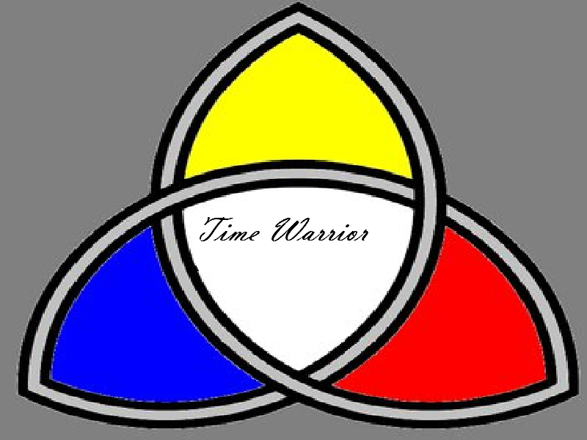

*Title screen not finalized.

*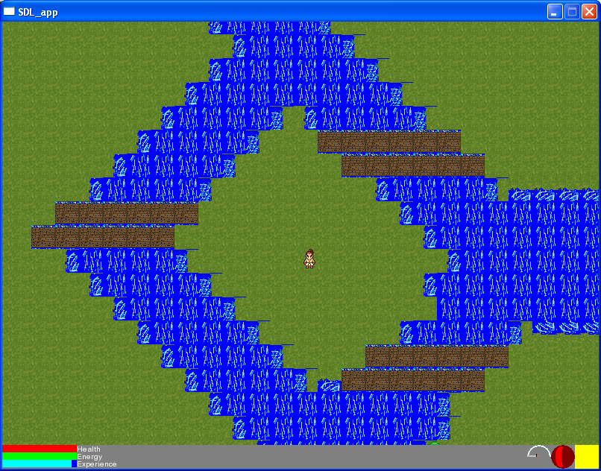

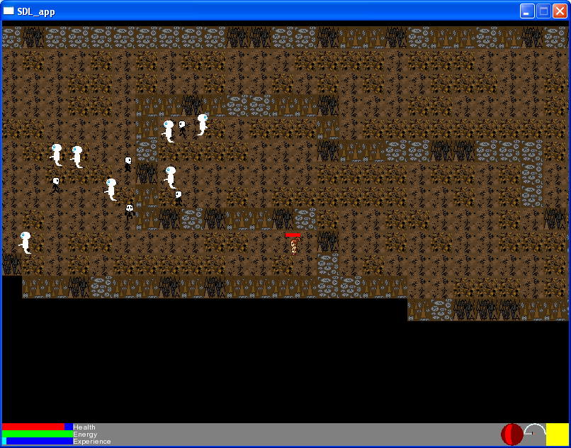*

*In-game screenshots. May not necessarily be present in final version.